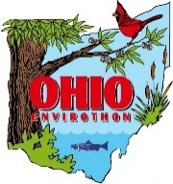

Area 3 & Ohio Envirothon Registration Form
Please type or neatly print

Team Name:
School Address:
School Phone:

Grade T-shirt
Student Names M/F Level Size
Team Captain:
Team Member:
Team Member:
Team Member:
Team Member:

Alternate:
Alternate:
Alternate:
Alternate:
Alternate:

Advisor 1
Name: | M/F:
Summer address: | Cell #:
E-mail address: | T-shirt Size:

Advisor 2
Name: | M/F:
Summer address: | Cell #:
E-mail address: | T-shirt Size:

NOTES: Only registered team members or alternates with signed release forms may participate in the Area or Ohio Envirothon. All teams must be registered by March 15, 2022. Alternate team members must be pre-registered, but may attend the Envirothon only if substituting for a registered team member who is unable to participate. All team members, alternates, and advisors must submit a release form with their registration form or the day of the event to participate.

Send completed registration forms by Tuesday, March 15, 2022 to: samanthadaugherty@coshoctoncounty.net

